Campus Network Design

1.1 Project Introduction:

**Project Abstract:**

In this network scenario, we establish an IP address allocation system using a single DHCP server in the Server room. Employed a Serial Connection to connect two routers and utilize the EIGRP routing protocol. This scenario focuses on designing an efficient LAN (Local Area Network) where various computers from different departments interact and exchange data. The objective is to create a well-structured network topology that enables seamless communication among multiple departments, meeting all network requirements. CNS delivers a high-performance network solution to fulfil these objectives.

**Components/Equipment:**

**End Device:**

* PC
* Printer
* Laptop

**Miscellaneous:**

* Switch

**Network Device:**

* Router

**Connection:**

We are using an Automatic connection here for our convenience.

* 1. IP Addressing Plan:

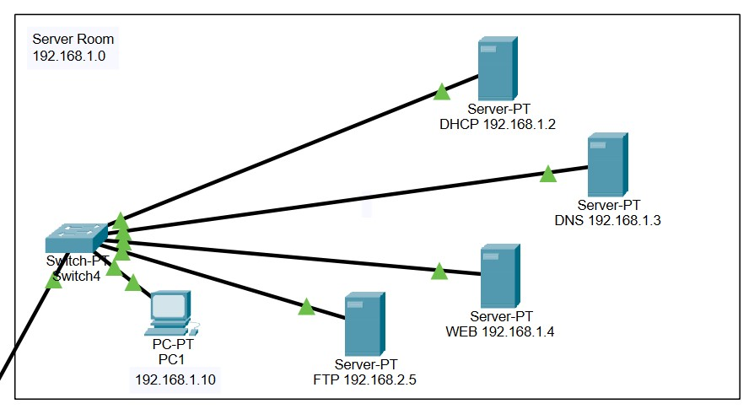

|  |  |  |  |  |  |
| --- | --- | --- | --- | --- | --- |
| **DEPARTMENT** | **COMPONENT** | **IP ADDRESS** | **DEFAULT GATEWAY** | **DNS SERVER** | **PRINTER**  **QUANTITY** |
| SERVER ROOM  (192.168.1.0) | DHCP SERVER | 192.168.1.2 | 192.168.1.1 | 192.168.1.3 | X |
| DNS SERVER | 192.168.1.3 |
| WEB SERVER | 192.168.1.4 |
| FTP SERVER | 192.168.1.5 |
| PC1 | 192.168.1.10 |

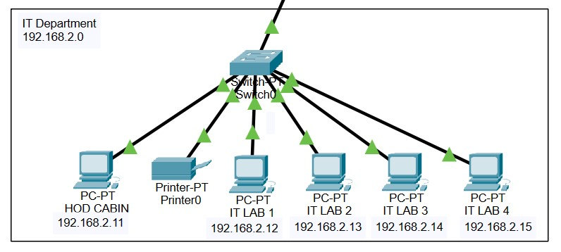

|  |  |  |  |  |  |
| --- | --- | --- | --- | --- | --- |
| **DEPARTMENT** | **COMPONENT** | **IP ADDRESS** | **DEFAULT GATEWAY** | **DNS SERVER** | **Printer**  **QUANTITY** |
| IT Department  (192.168.2.0) | HOD CABIN | 192.168.2.11 | 192.168.2.1 | 192.168.1.3 | 1 |
| IT LAB 1 | 192.168.2.12 |
| IT LAB 2 | 192.168.2.13 |
| IT LAB 3 | 192.168.2.14 |
| IT LAB 4 | 192.168.2.15 |

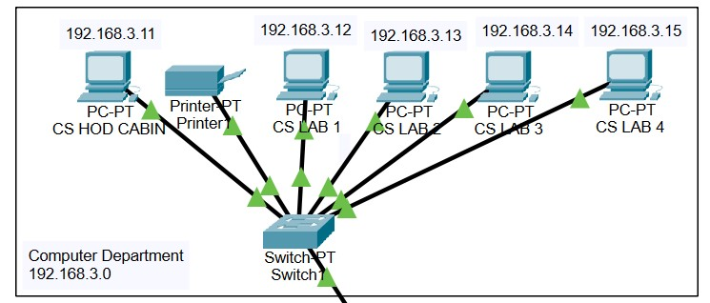

|  |  |  |  |  |  |
| --- | --- | --- | --- | --- | --- |
| **DEPARTMENT** | **COMPONENT** | **IP ADDRESS** | **DEFAULT GATEWAY** | **DNS SERVER** | **PRINTER**  **QUANTITY** |
| Computer  Department  (192.168.3.0) | CS HOD CABIN | 192.168.3.11 | 192.168.3.1 | 192.168.1.3 | 1 |
| CS LAB 1 | 192.168.3.12 |
| CS LAB 2 | 192.168.3.13 |
| CS LAB 3 | 192.168.3.14 |
| CS LAB 4 | 192.168.3.15 |

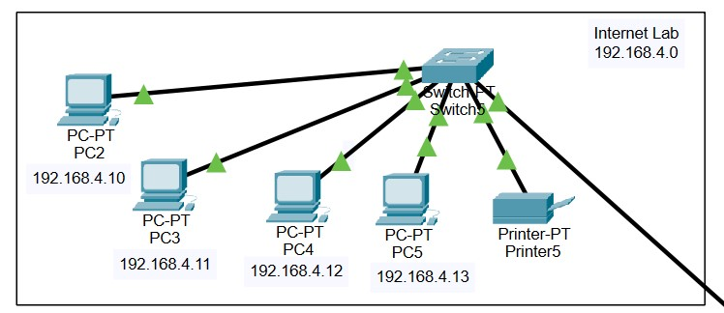

|  |  |  |  |  |  |
| --- | --- | --- | --- | --- | --- |
| **DEPARTMENT** | **COMPONENT** | **IP ADDRESS** | **DEFAULT GATEWAY** | **DNS SERVER** | **PRINTER**  **QUANTITY** |
| Internet Lab (192.168.4.0) | PC2 | 192.168.4.10 | 192.168.4.1 | 192.168.1.3 | 1 |
| PC3 | 192.168.4.11 |
| PC4 | 192.168.4.12 |
| PC5 | 192.168.4.13 |

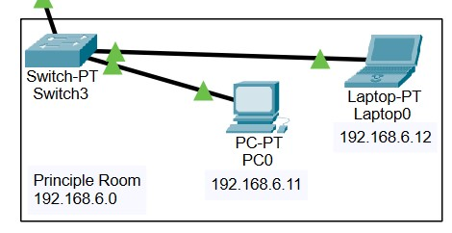

|  |  |  |  |  |  |
| --- | --- | --- | --- | --- | --- |
| **DEPARTMENT** | **COMPONENT** | **IP ADDRESS** | **DEFAULT GATEWAY** | **DNS SERVER** | **PRINTER**  **QUANTITY** |
| Principle Room (192.168.6.0) | PC 0 | 192.168.6.11 | 192.168.6.1 | 192.168.1.3 | x |
| LAPTOP 0 | 192.168.6.12 |

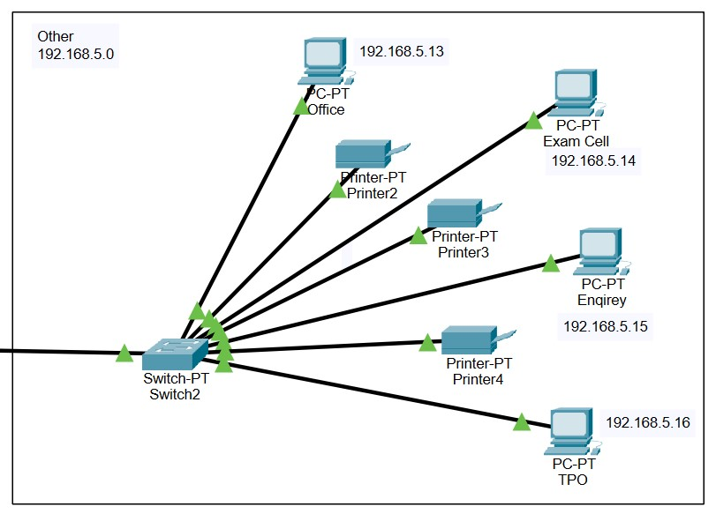

|  |  |  |  |  |  |
| --- | --- | --- | --- | --- | --- |
| **DEPARTMENT** | **COMPONENT** | **IP ADDRESS** | **DEFAULT GATEWAY** | **DNS SERVER** | **PRINTER**  **QUANTITY** |
| Other (192.168.5.0) | OFFICE | 192.168.5.13 | 192.168.5.1 | 192.168.1.3 | 3 |
| EXAM CELL | 192.168.5.14 |
| ENQUIRY | 192.168.5.15 |
| TPO | 192.168.5.16 |

* 1. Routing Protocol Plan:

**Project Abstract:**

Certainly, we used the EIGRP routing protocol for our project. Here are the details about the EIGRP (Enhanced Interior Gateway Routing Protocol) routing protocol:

1. **Introduction:**

* + EIGRP, or Enhanced Interior Gateway Routing Protocol, is a Cisco-proprietary routing protocol used for routing within a network or Autonomous System (AS). It's designed to provide fast convergence, scalability, and efficient use of network bandwidth.

1. **Features:**

* + **Hybrid Protocol:** EIGRP combines distance vector and link-state routing features, contributing to its efficiency and fast convergence.
  + **Advanced Metrics:** EIGRP uses various metrics (bandwidth, delay, reliability, load) to calculate the best path to a destination.
  + **VLSM Support:** EIGRP can work with Variable Length Subnet Masks (VLSM) and allows route summarization.
  + **Rapid Convergence:** It can quickly adapt to network topology changes, minimizing downtime.
  + **Reduced Network Traffic:** EIGRP only updates when network changes occur, reducing unnecessary traffic.
  + **Load Balancing:** EIGRP supports equal-cost load balancing, distributing traffic across multiple paths.
  + **Authentication:** It provides security through authentication mechanisms.
  + **Loop Prevention:** EIGRP uses the Diffusing Update Algorithm (DUAL) to prevent routing loops.

1. **Terminology:**

* + **EIGRP Router:** A device running EIGRP.
  + **Neighbor:** Routers within the same EIGRP routing domain that exchange routing information.
  + **AS (Autonomous System):** A collection of routers under the control of a single organization and using a common routing protocol.

1. **Operations:**

* EIGRP routers periodically exchange routing updates.
* The routers maintain a topology table to track network information.
* DUAL is used to calculate the best path to a destination based on various metrics. • EIGRP routers send updates to their neighbors, ensuring they have consistent routing information.
* Split horizon and route poisoning are used to prevent routing loops.

1. **Configuration:**

* + To configure EIGRP on a Cisco router, you typically specify the ASN (Autonomous System Number) and the networks to be advertised.
  + Authentication keys can be set for security.

1. **Advantages:**

* + EIGRP is fast in converging routing updates, reducing network downtime.
  + It's efficient in using network bandwidth due to its updates being triggered by network changes.
  + Load balancing across equal-cost paths can optimize network performance.
  + Route summarization can simplify routing tables.

1. **Disadvantages:**

* + EIGRP is a Cisco-proprietary protocol, which limits its use in multi-vendor networks.
  + It's more complex to configure compared to some other routing protocols.
  + The Advanced Distance Vector approach may not be as scalable as pure linkstate protocols.

1. **Common Uses:** 
   * + EIGRP is often used in Cisco-centric networks where multi-vendor interoperability is not a concern.
     + It's suitable for medium to large-sized networks where efficient routing and fast convergence are critical.

EIGRP is a robust and efficient routing protocol that works well within Cisco-based networks, especially when rapid convergence and bandwidth efficiency are important factors. It's widely used in enterprise networks and can be valuable to network design and management.

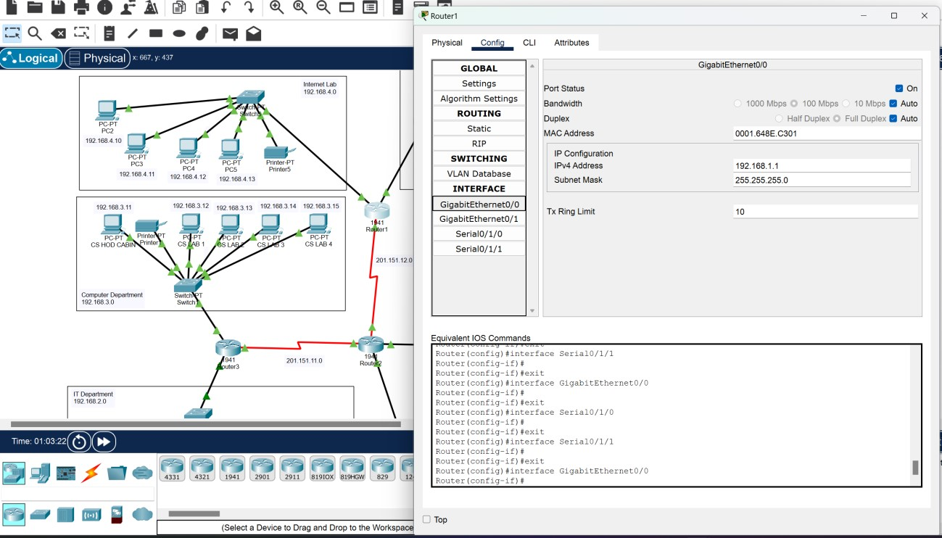

# Routing Protocol Plan for Router1

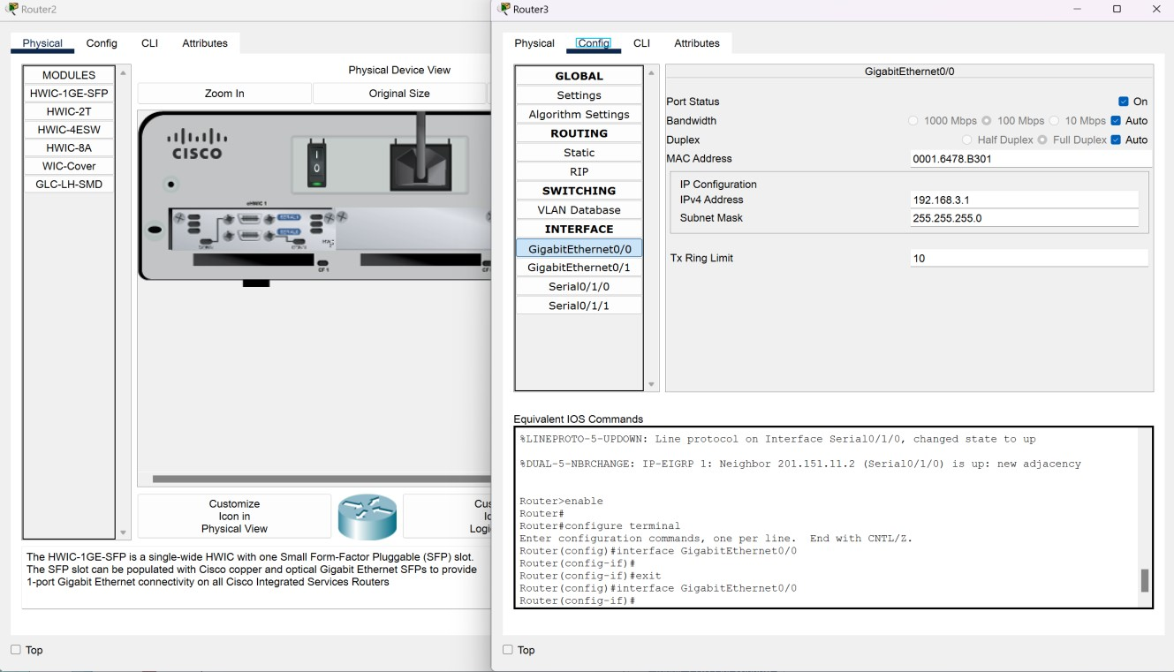 *Routing Protocol Plan for Router2 Routing Protocol Plan for Router3*

1.4 Command Line Interface (CLI) for EIGRP Routing Protocol:

**Router1:**

Router>enable

Router#

Router#configure terminal

Router(config)#interface Serial0/1/0

Router(config-if)#exit

Router(config)#router eigrp 1

Router(config-router)#network 192.168.1.0 255.255.255.0

Router(config-router)#network 192.168.4.0 255.255.255.0

Router(config-router)#network 201.151.12.0 255.255.255.0

Router(config-if)#exit

Router(config)#interface GigabitEthernet0/1

Router(config-if)#ip helper-address 192.168.1.2

**Router2:**

Router>enable

Router#

Router#configure terminal

Router(config)#interface Serial0/1/0

Router(config)#router eigrp 1

Router(config-router)#network 192.168.5.0 255.255.255.0

Router(config-router)#network 192.168.6.0 255.255.255.0

Router(config-router)#network 201.151.12.0 255.255.255.0

Router(config-router)#network 201.151.11.0 255.255.255.0

Router#

Router#configure terminal

Router(config)#interface GigabitEthernet0/0

Router(config-if)#ip helper-address 192.168.1.2

Router(config)#interface GigabitEthernet0/1

Router(config-if)#ip helper-address 192.168.1.2

**Router3:**

Router(config-if)#exit

Router(config)#interface Serial0/1/0

Router(config-if)#exit

Router(config)#router eigrp 1

Router(config-router)#network 192.168.3.0 255.255.255.0

Router(config-router)#network 192.168.2.0 255.255.255.0

Router(config-router)#network 201.151.11.0 255.255.255.0

Router>enable

Router#

Router#configure terminal

Router(config)#interface GigabitEthernet0/0

Router(config-if)#ip helper-address 192.168.1.2

Router(config)#interface GigabitEthernet0/1 Router(config-if)#ip helper-address 192.168.1.2

1.5 Network Design:

We establish an IP address allocation system using a single DHCP server 192.168.1.2 located in the Server room. Furthermore, we implement custom HTTP code for the WEB and FTP servers.

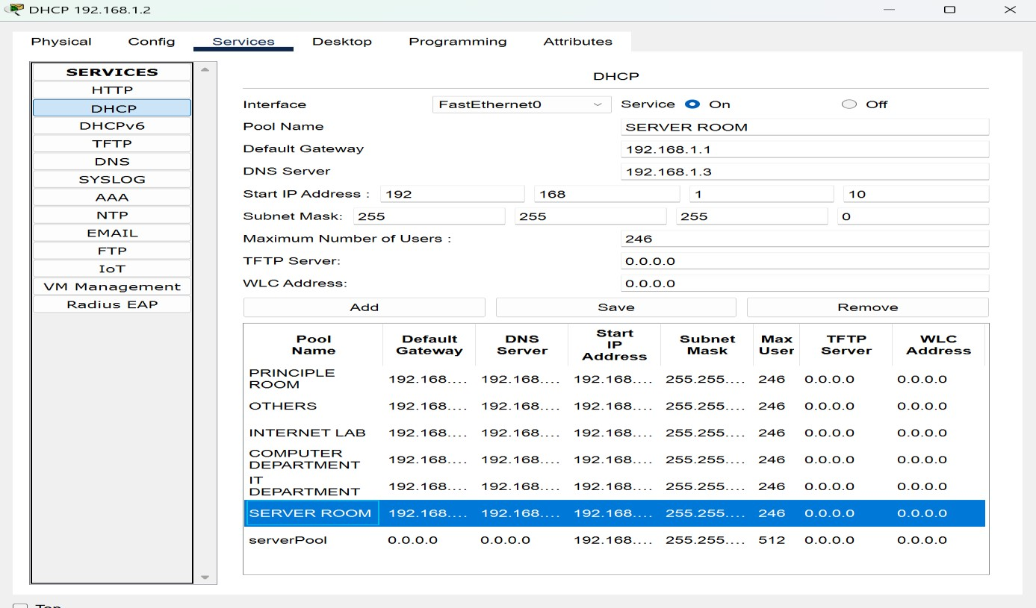

*The prototype of the DHCP Server this network*

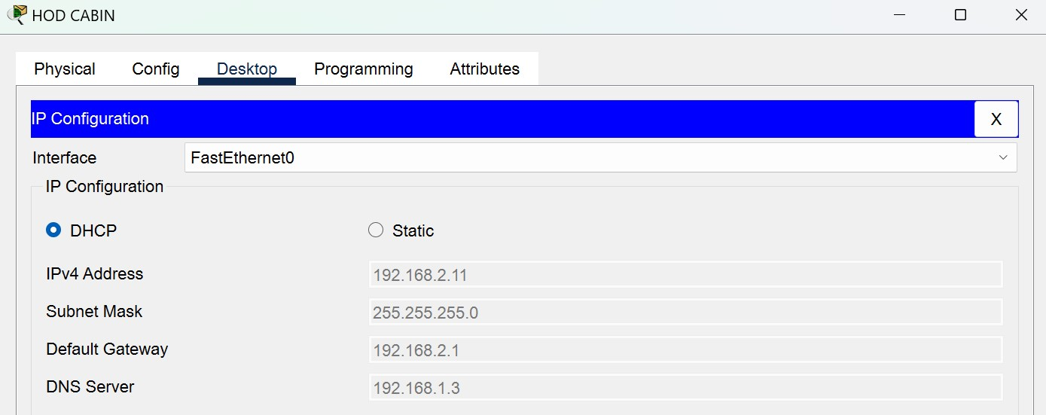

# IP assigned with DHCP Server

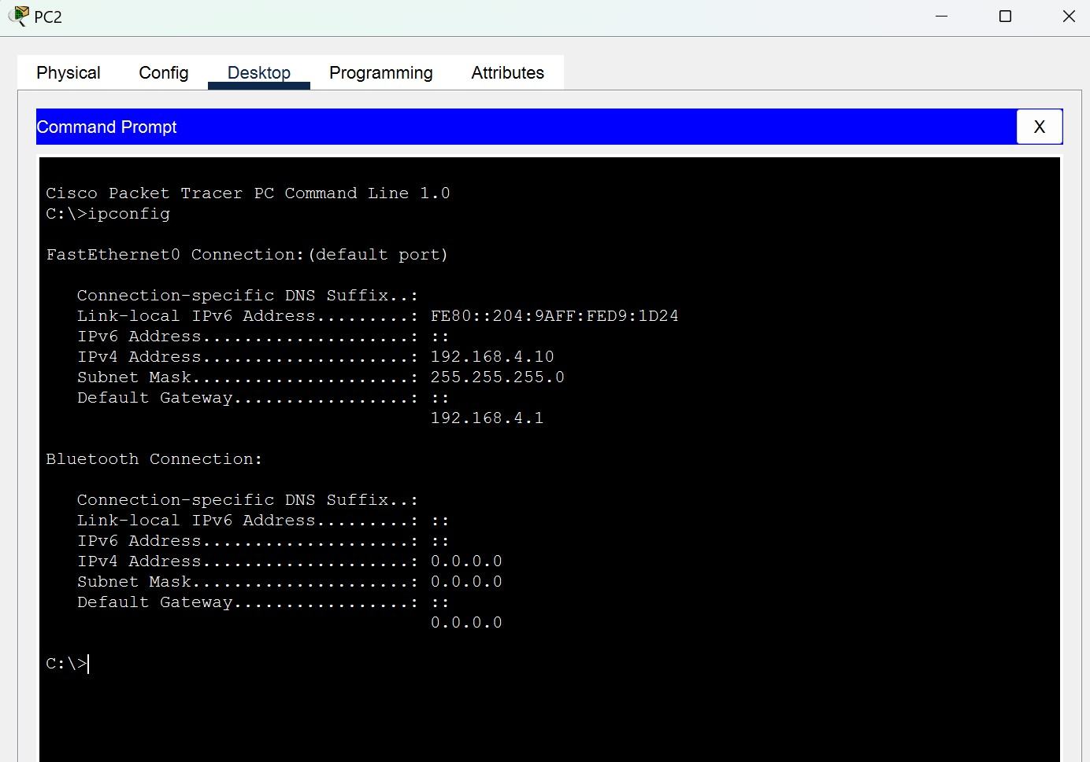

# Testing ipconfig command prompt

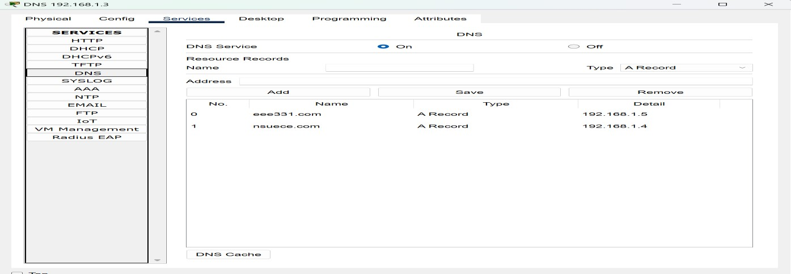

# DNS SERVER

# 

*We can successfully send packets through that scenario, which we have discussed.*